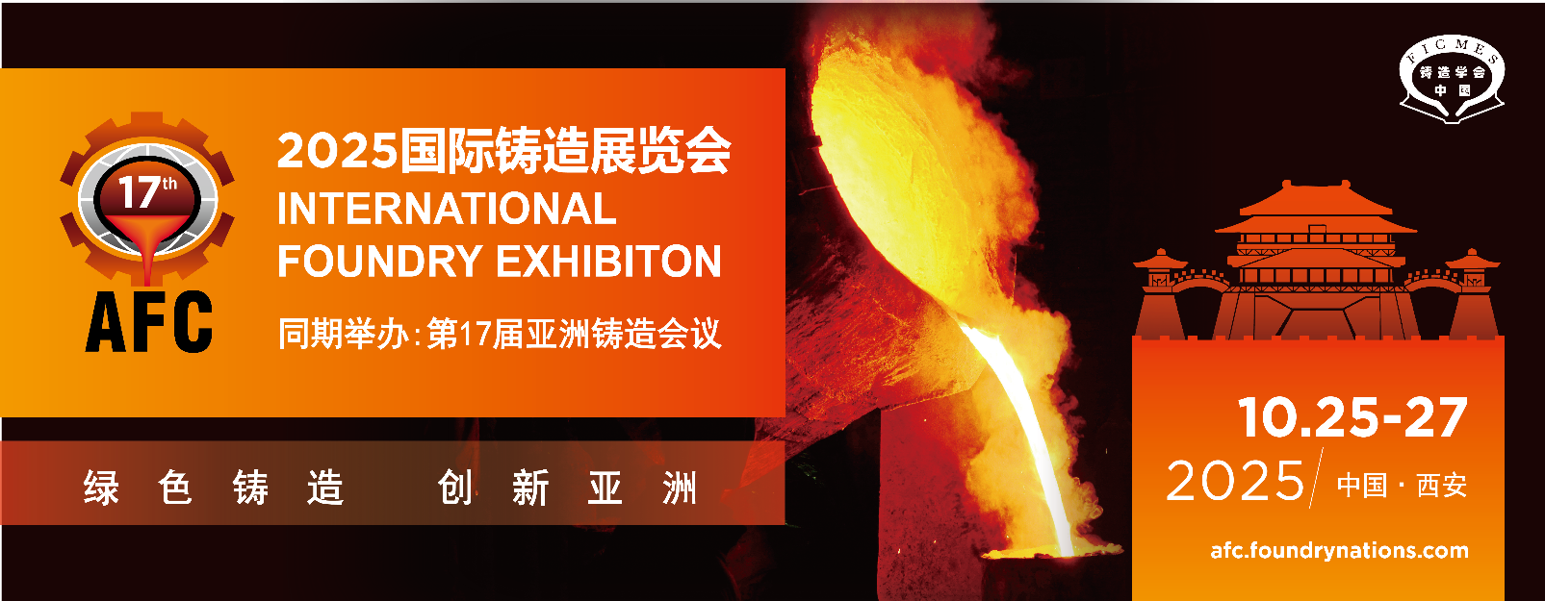

|  |  |
| --- | --- |
| **1. Company Information** | **2. Co-Exhibiting Company (max. 1 co-exhibitor per 9 sqm)** |
| Company Name_____________________________________  Address ___________________________________________  Contact Person Mr. /Ms. ______________________________  Division & Position___________________________________  Phone ____________________________________________  Fax ______________________________________________  E-mail ____________________________________________  Website www.______________________________________ | Company Name_____________________________________  Address ___________________________________________  Contact Person Mr. /Ms. ______________________________  Division & Position___________________________________  Phone ____________________________________________  Fax ______________________________________________  E-mail ____________________________________________  Website www. ______________________________________ |

|  |  |  |
| --- | --- | --- |
| **3. Products** (Please tick as appropriate) | | |
| □1. Metal casting parts  □2. Casting machine  □3. Peripheral equipment  □4. Furnaces and accessories  □5. Moulds and accessories  □6. Rapid prototyping/rapid tooling | □7. Casting machine parts  □8. Moulding materials  □9. Raw materials  □10. Auxiliaries  □11. Software  □12. After treatment of castings/CNC treatment | □13. Surface technology  □14. Detection equipment  □15. Environmental protection instrument and safety equipments  □16. Industry service  □17. Others________________ |

|  |  |  |
| --- | --- | --- |
| **4. Booth Rental** | | |
| * **Option 1: Shell Scheme Package (min. 9 sqm = 3m x 3m)** | ____sqm | USD 3,000 / 9 sqm |
| * **Option 2: Raw Space Only (min. 18 sqm)** | ____sqm | USD 280 / sqm |
| * **Co-exhibition fee**   Max. one co-exhibiting company per 9 sqm stand booking is allowed. The co-exhibitor fee cover full listing in show directory, promotion and company name on fascia. | _______  co-exhibitor(s) | USD 600 / co-exhibiting  company |
| **\* 10% discount (rental fee only) before May 30, 2025** | | |
| Total Amount | | USD ______ |

*Company Authorized Signature and company seal:* *Date:*

|  |  |
| --- | --- |
| Foundry Institution of Chinese Mechanical Engineering Society (FICMES) | Contact: Ms. Gillian Li  E-mail: liangyujia@foundrynations.com  Tel: +86 24 25855793 |